T: 800.503.4417 ext. 1 | E: sales@p3adaptive.com | W: www.p3adaptive.com
Power BI User Access & Report Sharing Recommendations
Prepared For:
United Performance Metals (UPM)
Prepared By:
Kristyna Ferris
Solutions Architect
kferris@p3adaptive.com
Date Created: | October 2, 2024
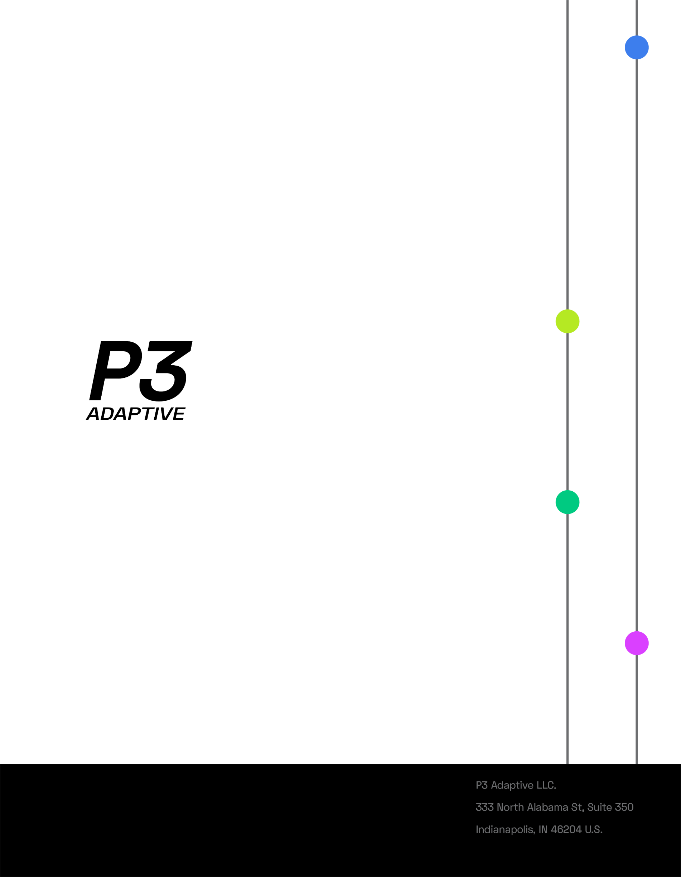

Executive Summary
P3 Adaptive completed a thorough Power BI strategic assessment including a Tenant Setting Analysis, report sharing best practices, data modeling best practice, and licensing options. In addition to the contents of this documentation, P3 also provided a Power BI Management report and list of datasets to consolidate.
This document covers our best practices for user access and report sharing. As a general guide, avoid sharing with users individually and adopt the principle of least privilege. We recommend granting access to users through a security group instead of individually. This will make sharing reports by business much easier. For example, if you have ten workspaces and the finance team needs access to all of them, you can create a security group with all the finance team and share those workspaces with that security group. Then, if the finance team adds two new people and one person leaves the company, you only need to adjust the security group membership in one place and the Power BI access will automatically adjust. That will save you from having to add those two users to all 10 workspaces and remove anyone who leaves the company. Ideally, you could work with the HR team to have the process of adding or removing users during the onboarding and offboarding process.

User Access

Best practices
- Use service accounts/security groups for access, not named users.
- Only grant Workspace access to admins and developers.
- Use service accounts/security groups for semantic model ownership, tenant administration, and workspace administrators.
- Adopt the principle of least privilege.

Details
Power BI Service offers an array of security levels, cascading from datasets to reports to workspaces to apps. The best practice is to employ the principle of least privilege by providing users with the minimal permissions necessary to fulfill their job responsibilities. It's also recommended to restrict the number of named users with access, favoring the use of service accounts instead.
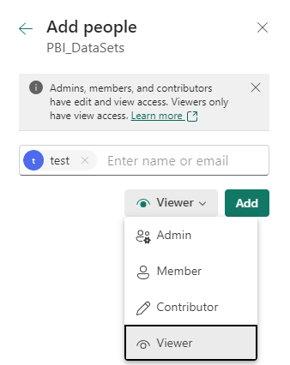
Very few users or service accounts should have Admin access on any given Workspace. Aside from Admin, there are 3 other levels of permissions in Power BI: Member, Contributor, and Viewer. A Member still has a great deal of abilities, including adding and removing others, so it should be used sparingly. Contributor role is ideal for report authors as they will have full control over their content, but not other’s content in the workspace. Lastly, Viewers can read content, but they also can share content if allowed by the content author.
Figure 2: User Access Levels in the Service

Report Sharing

Best practices
- Primarily use Apps for consumer viewing.

Details
The recommended best practice is to only share reports to consumers by using Apps. There are several reasons Apps are the preferred method of sharing out reports.
One main reason is the app interface is greatly simplified compared to stand-alone reports; otherwise, users may be overwhelmed with all the artifacts in a Workspace or even on a stand-alone report. Multiple reports can be combined with documentation and web links in an App, which gives users less artifacts to keep track of as well. Lastly, separating the reports from the apps adds another layer of Quality Assurance (QA) as reports can be published to a Workspace, but aren’t included in the app until explicitly updating the app. Using Apps for report consumption benefits both the consumers and the creators. Radacad has an excellent article on how to set up and use apps and audiences that we recommend referring to: Ultimate Sharing Strategy: Power BI Apps - RADACAD.

